Academic Year | 2025 - 26 | Experiment No. | 1
Course & Semester | S.E. – Sem. IV | Subject Name | Web Programming
Experiment Type | Software Performance | Subject Code | 25VSE12CS03

Name of Student: | Atharva Dharmendra Jagtap | Roll No.: | 10937
Date of Performance: | 09-02-2026 | Date of Submission: | 09-02-2026
LO Mapping | 25VSE12CS03.1: Apply JavaScript, HTML5 and CSS3 effectively to create interactive and dynamic websites.

Indicator | Poor | Average | Good
Timeline Maintains submission deadline (3) | Submission not done (0) | One or More than One week late (1-2) | Maintains deadline (3)
Completion and Organization (3) | N/A | Document is just acceptable (1-2) | Completed whole document and neatly organized (3)
Program Performance (2) | Could not perform at all (0) | Implemented few parts (1) | Full implementation (2)
Knowledge In depth knowledge of the Experiment (2) | Unable to answer questions (0) | Unable to answer few questions (1) | Able to answer all questions (2)

Assessment Marks:
Timeline
Completion and Organization
Program Performance
Knowledge

Total: (Out of 10)
Teacher’s Sign: Student Sign:

Experiment No. 1

- Aim:
Develop a web page using HTML5 tags. (USE- IMAGE, LINKS, TABLE, FORM, LIST, SEMANTIC ELEMENTS, HTML5 FEATURES- audio, video, drag-drop, geolocation, canvas).

- Objective:
The objective of this problem statement is to develop a comprehensive and interactive web page using modern HTML5 features and best practices. The web page should include various HTML5 elements .The goal is to create a functional, user-friendly, and visually appealing web page that demonstrates the utilization of HTML5 features and adheres to web development standards.

- Theory:
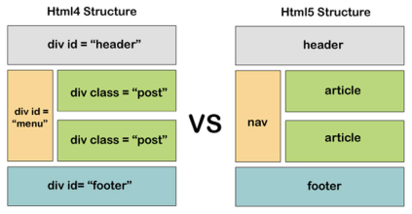
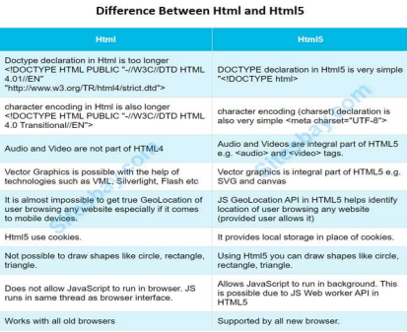

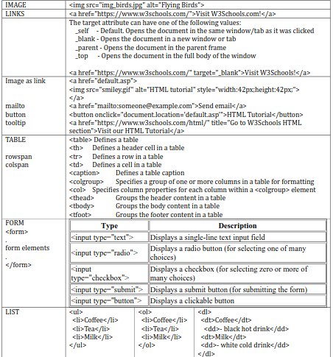
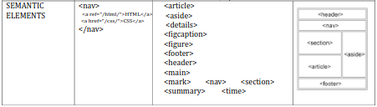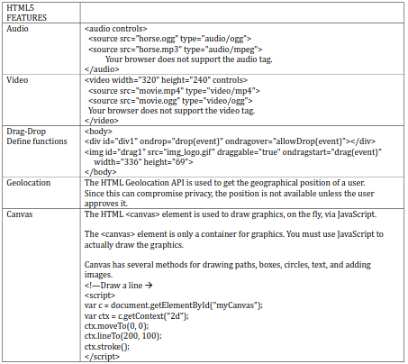

- Implementation:
<!DOCTYPE html>
<html lang="en">
<head>
<meta charset="UTF-8">
<title>Portfolio — Atharva</title>
</head>
<body>

<!-- Header with Navigation -->
<header>
<h1>Portfolio – Atharva</h1>
<nav>
<a href="#about">About</a> |
<a href="#projects">Projects</a> |
<a href="#contact">Contact</a>
</nav>
</header>

<!-- Section: About -->
<section id="about">
<h2>About Me</h2>
<p>Hello, I am Atharva — a web developer passionate about building interactive experiences.</p>
<img src="https://atharva9167j.github.io/profile.png" alt="Atharva GitHub Avatar" width="200">
</section>

<!-- Section: Project List -->
<section id="projects">
<h2>My Projects</h2>
<ul>
<li><a href="https://atharva9167j.github.io">Personal GitHub Pages</a></li>
<li>Interactive Web Games</li>
<li>Canvas Drawing Tools</li>
</ul>

<!-- Table of Skills -->
<table border="1">
<tr><th>Skill</th><th>Level</th></tr>
<tr><td>HTML5</td><td>Advanced</td></tr>
<tr><td>JavaScript</td><td>Intermediate</td></tr>
<tr><td>Web Security</td><td>Intermediate</td></tr>
</table>
</section>

<!-- Multimedia Features -->
<section>
<h2>Audio & Video Demo</h2>
<audio controls>
<source src="sample-audio.mp3" type="audio/mpeg">
Your browser does not support audio.
</audio>
<br>
<video width="320" controls>
<source src="sample-video.mp4" type="video/mp4">
Your browser does not support video.
</video>
</section>

<!-- Canvas Drawing -->
<section>
<h2>Canvas Demo</h2>
<canvas id="demoCanvas" width="300" height="150" style="border:1px solid black;">
Your browser does not support Canvas.
</canvas>
<script>
const c = document.getElementById("demoCanvas");
const ctx = c.getContext("2d");
ctx.fillStyle = "#0099FF";
ctx.fillRect(20, 20, 200, 100);
ctx.fillStyle = "#ffffff";
ctx.font = "20px Arial";
ctx.fillText("Hello Canvas", 40, 80);
</script>
</section>

<!-- Drag & Drop -->
<section>
<h2>Drag & Drop Demo</h2>
<p>Drag the box into the drop area:</p>
<div id="dragItem" draggable="true" style="width: 100px; height: 100px; background: orange;">
Drag Me
</div>
<div id="dropArea" style="width: 200px; height: 150px; border: 2px solid #000; margin-top: 10px;">
Drop Here
</div>
<script>
const dragItem = document.getElementById("dragItem");
const dropArea = document.getElementById("dropArea");

dragItem.addEventListener("dragstart", ev => {
ev.dataTransfer.setData("text", ev.target.id);
});
dropArea.addEventListener("dragover", ev => {
ev.preventDefault();
});
dropArea.addEventListener("drop", ev => {
ev.preventDefault();
const id = ev.dataTransfer.getData("text");
ev.target.appendChild(document.getElementById(id));
});
</script>
</section>

<!-- Geolocation -->
<section>
<h2>Geolocation</h2>
<button onclick="getLocation()">Get My Location</button>
<p id="locationText"></p>
<script>
function getLocation() {
if (navigator.geolocation) {
navigator.geolocation.getCurrentPosition(p => {
document.getElementById("locationText").textContent =
"Latitude: " + p.coords.latitude + ", Longitude: " + p.coords.longitude;
});
} else {
document.getElementById("locationText").textContent = "Geolocation not supported.";
}
}
</script>
</section>

<!-- Contact Form -->
<section id="contact">
<h2>Contact Me</h2>
<form action="#" method="post">
<label>Name: <input type="text" name="name" required></label><br>
<label>Email: <input type="email" name="email" required></label><br>
<label>Message:<br>
<textarea name="message" rows="4" cols="30" required></textarea>
</label><br>
<input type="submit" value="Send">
</form>
</section>

<!-- Footer -->
<footer>
<p>&copy; 2026 Atharva</p>
</footer>
</body>
</html>

Output:
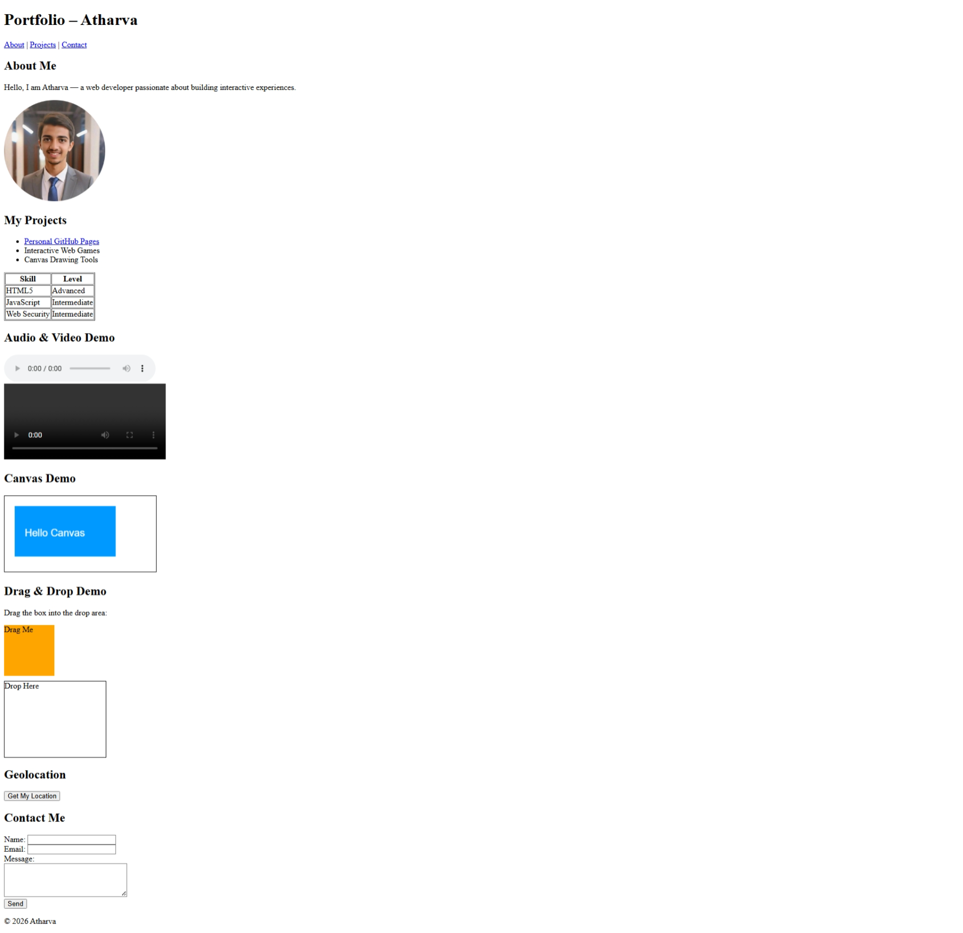

Post Lab Question :
- What is the purpose of the anchor tag in HTML5? How can you create a hyperlink to another web page and to a specific section within the same page?
Sol. Purpose of the <a> tag in HTML5
- Creates hyperlinks to other web pages or sections.
- Link to another page:
<a href="https://example.com">Visit Example</a>
- Link to a section within the same page:
<a href="#contact">Go to Contact</a>
  - Uses IDs to jump to anchored sections.

- What are the differences between using the img tag and the picture element in HTML5?
Sol. Differences between <img> and <picture> elements
Feature | <img> | <picture>
Purpose | Displays a single image | Provides responsive images with multiple sources
Source set control | No | Yes, through <source> elements
Best use | Standard images | Adaptive images for different screen sizes
Example | <img src="img.jpg" alt="demo"> | <picture> <source media="(max-width:600px)" srcset="small.jpg"> <source media="(min-width:601px)" srcset="large.jpg"> <img src="fallback.jpg" alt="responsive"> </picture>

- What are some new input types introduced in HTML5? Describe their uses with examples ?
Sol. New Input Types in HTML5 (with Uses)
Input Type | Purpose | Example
email | Validates email format | <input type="email">
tel | Phone number input | <input type="tel">
url | Website URL validation | <input type="url">
date | Date selection UI | <input type="date">
range | Slider input | <input type="range">
number | Numeric input | <input type="number">

- Conclusion:
This HTML5 portfolio demonstrates modern web features without CSS:
- Semantic structure: header, section, footer.
- Multimedia integration: audio and video playback.
- Interactive APIs: canvas drawing, drag & drop, geolocation.
- Forms & navigation: user input and internal links.
- Accessible design: meaningful tags and labels.
The page meets HTML5 standards and showcases practical use of each required element.

